
Team Assignment 09
HIT
3/17/2012

Software Measurement and Analysis

Team members: | Members ID
Giang Thị Ha Thanh | T097828
Trần Dũng Đạt | T095716
Nguyễn Vũ Trọng Giang | T096656
Huỳnh Chấn Huy | T096498
Tạ Quang Hiệp | T090363
Nguyễn Trần Hồng Phúc | T095014

Analyzes the Viking project’s earned value data and submits a report (<3 pages) on your findings. Assume that the date of your report is at the end of Week 28

- Metrics
  - Intended Audience
- Functional Test Manager
- Project Manager
- Change Control Board (CCB)
- Functional test team members

  - Goal / Question / Metric
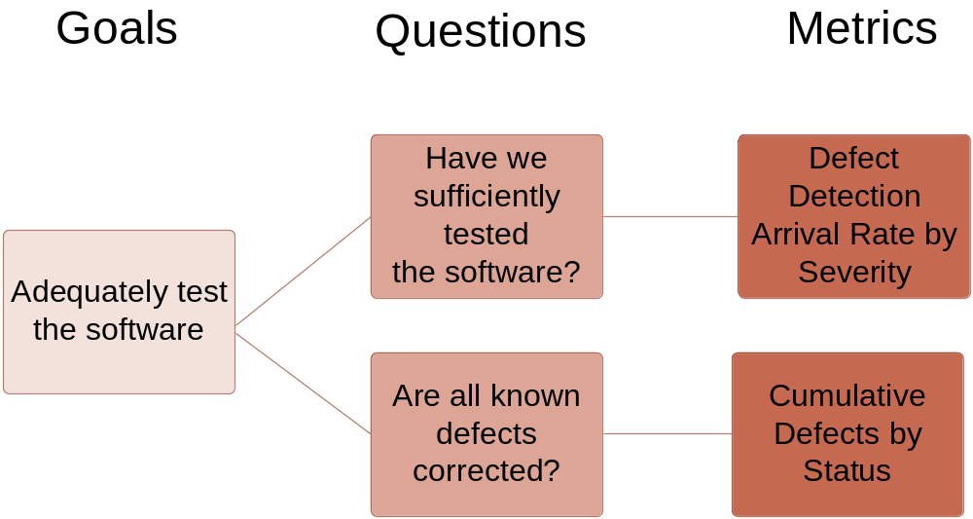

- Defect Detection Arrival Rate by Severity Metric
  - Metric Requirement Statement
To evaluate the detection arrival rate by severity of defect in this release in order to deliver our software product with required quality and insure that all known defects are corrected before shipment.
  - Standardized Definitions
Severity Levels: The importance of the problem, as defined by the customer (typically based on the problem’s impact on the user). There are four levels of Serverity:
1 – Critical
2 – High
3 – Medium
4 – Low
  - Decision Criteria
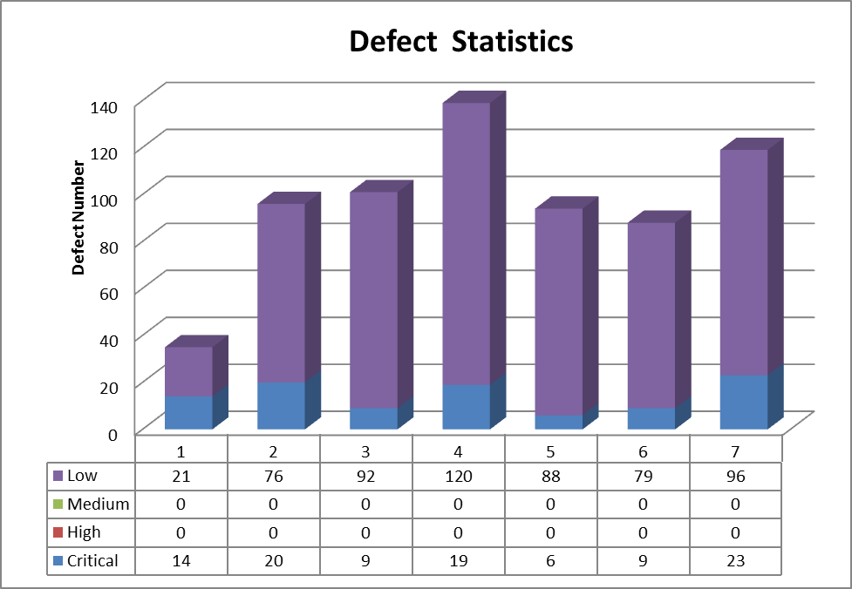

- Cumulative Defects By Status
  - Metric Requirements Statement
To evaluate the number by status of the known defects in this release in order to deliver our software product with required quality and ensure that all know defects are corrected before shipment.
  - Standardized Definitions
Status | Status Meaning
Open | New, not yet assigned
Reopen | A defect that was previously Closed, Pending or Rejected has been Reopened. Typically this means that the Customer or QA has been able to reproduce the defect.
Rejected | From the evaluation it has been determined that this is either not a defect or it can't/won't be resolved.
Further Analysis | From the evaluation it has been determined that additional analysis is required
Pending | Additional information has been requested from the person who submitted the defect
Approved | The defect has been approved for resolution
Assigned | The defect has been assigned to a software engineer who will work on the defect
Resolved | The software engineer responsible for fixing the defect believes that the defect is fixed. Typically this means that the updated product passes all unit and integration tests.
Tested | The defect is considered resolved by the QA team
Closed | The updated product is available for release. Sometimes the original defect submitter is responsible for closing defects, but often this isn't possible.

- Related Document
Viking_Product_Defect_Data (Excel file)

